[YOUR NONPROFIT] Fundraising Page Setup

Thank you for partnering with us! You can create your personal [YOUR CAMPAIGN NAME] fundraising page in 2 minutes by following the steps below:

1. Go to [ORGANIZATION’S CROWDFUNDING PAGE URL] to access the [YOUR CAMPAIGN NAME] fundraising page template.

2. Click on Create my own fundraising page! to build your personal page.

3. Enter the Name for the fundraising page owner, such as “John Smith’s Team.” This name will be visible to everyone who visits your page.

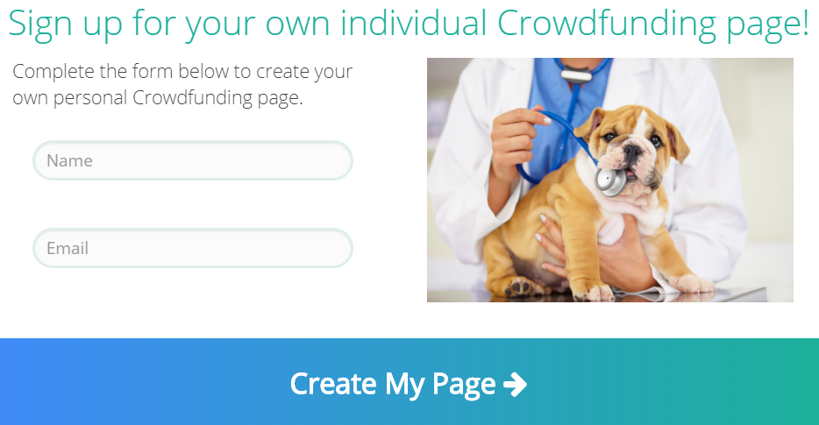

4. Enter the fundraising page owner’s email address. Your confirmations will go to this email address.

5. Click Create My Page and then click on Okay.

6. In your email inbox, find the email with the subject line “Personalize your Crowdfunding page.” (If you cannot find it, please check your Junk or Spam folder.) Save this email so that you can edit your page later if needed.

7. In the email, click on the Personalize my page! button to go to your personal fundraising page.

8. In the Page Editor, you can personalize your page by clicking the edit (pencil) icon next to certain sections: (These are all optional)

- Update how your name appears under the page’s title.
- Set a personal fundraising goal for just your page. The overall goal for [CAMPAIGN NAME] is [$AMOUNT].
- Turn on/off Show Supporter List. (checkbox)
- Replace the default [CAMPAIGN NAME] image with your own image.
- Type your own message to everyone who views your page.

9. When finished editing your page, click on Save and Publish.
Then, click Got It! in the window that pops up.

10. In your inbox, find the email with the subject line “Support my fundraising effort.” Save this email so that you can use it later if needed.

11. Forward this email to as many family, friends, and colleagues as you can. Before sending:
- Change the subject line to avoid your email going into others’ Junk email folders.
- Delete the “Forward” tip message at the top of the email.
- Personalize your email message.

12. To share your page on social media, right-click Donate to my cause and select copy link address. Then, paste the link into your social media accounts.
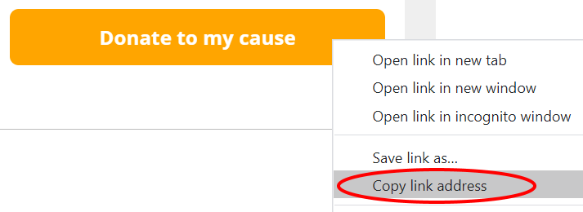

You have finished. Thank you for your support!

Questions? Please contact [CONTACT NAME + TITLE]
at [CONTACT EMAIL ADDRESS] or [CONTACT PHONE NUMBER].

